**Comprehensive Guide to Python Visualization Libraries: Matplotlib & Seaborn**

**Table of Contents**

1. **Introduction**
2. **Library Overview**
   * Matplotlib
   * Seaborn
3. **Graph Types and Examples**
   * Line Plots
   * Scatter Plots
   * Bar Charts
   * Histograms
   * Pie Charts
   * Box Plots**Comprehensive Guide to Python Visualization Libraries: Matplotlib & Seaborn**
   * **Table of Contents**
   * **Introduction**
   * **Library Overview**
   * Matplotlib
   * Seaborn
   * **Graph Types and Examples**
   * Line Plots
   * Scatter Plots
   * Bar Charts
   * Histograms
   * Pie Charts
   * Box Plots
   * Heatmaps
   * Violin Plots
   * **Comparison of Features**
   * Ease of Use
   * Customization Options
   * Interactivity
   * Performance with Large Datasets
   * **Conclusion**
   * **References**
   * Heatmaps
   * Violin Plots
4. **Comparison of Features**
   * Ease of Use
   * Customization Options
   * Interactivity
   * Performance with Large Datasets

**1. Introduction**

Data visualization is an essential part of data analysis, helping to convey insights effectively. Python provides multiple powerful visualization libraries, among which Matplotlib and Seaborn are widely used. This guide explores these libraries, comparing their features and providing practical examples.

**2. Library Overview**

**Matplotlib**

Matplotlib is a comprehensive library for creating static, animated, and interactive visualizations in Python. It provides fine-grained control over plots and is highly customizable.

* **Key Features:**
  + Supports various chart types
  + Highly customizable
  + Can be used with NumPy and Pandas
  + Generates publication-quality figures
* **Use Cases:**
  + Scientific computing
  + Academic research
  + Custom visualizations

**Seaborn**

Seaborn is built on top of Matplotlib and provides a high-level interface for drawing attractive and informative statistical graphics.

* **Key Features:**
  + Simplifies complex visualizations
  + Integrated with Pandas DataFrames
  + Default aesthetic styles
  + Supports statistical plotting
* **Use Cases:**
  + Exploratory Data Analysis (EDA)
  + Statistical data visualization
  + Heatmaps and categorical plots

# ****2. Graph Types and Examples****

Each library supports a variety of graph types useful for different analytical purposes. Below is an overview of commonly used graphs with examples.

## ****2.1 Line Plot****

### ****Use Case:**** Trend analysis over time.

**Matplotlib Example:**

import matplotlib.pyplot as plt

import numpy as np

t = np.arange(0., 5., 0.2)

plt.plot(t, t**2, 'r--', label="Squared")

plt.xlabel('Time')

plt.ylabel('Value')

plt.legend()

plt.show()

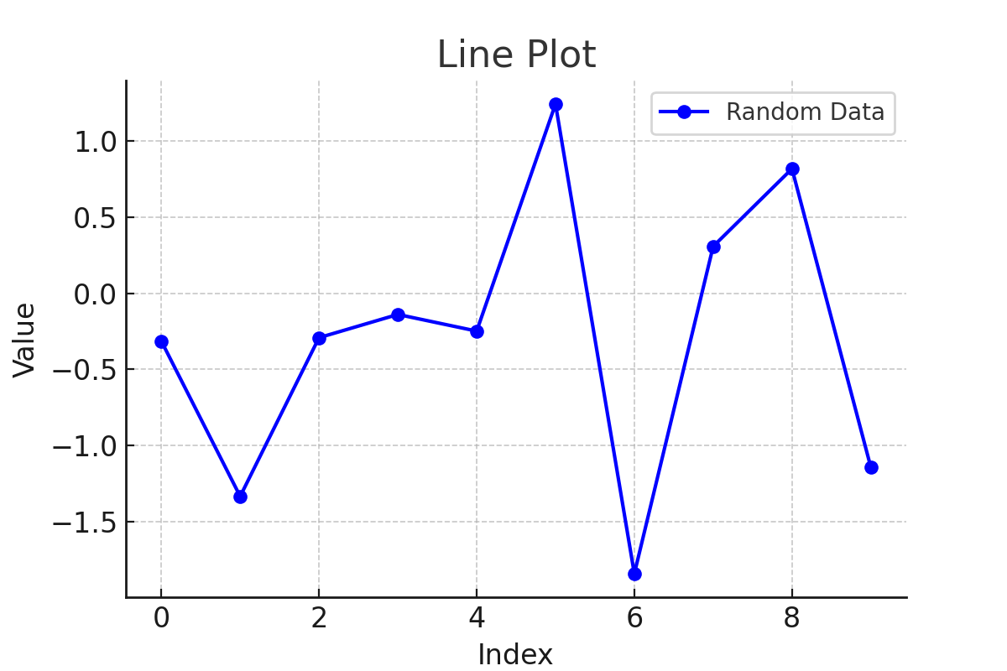

**Seaborn Example:**

import seaborn as sns

import pandas as pd

import numpy as np

df = pd.DataFrame({'x': np.linspace(0, 10, 100), 'y': np.sin(np.linspace(0, 10, 100))})

sns.lineplot(x='x', y='y', data=df)

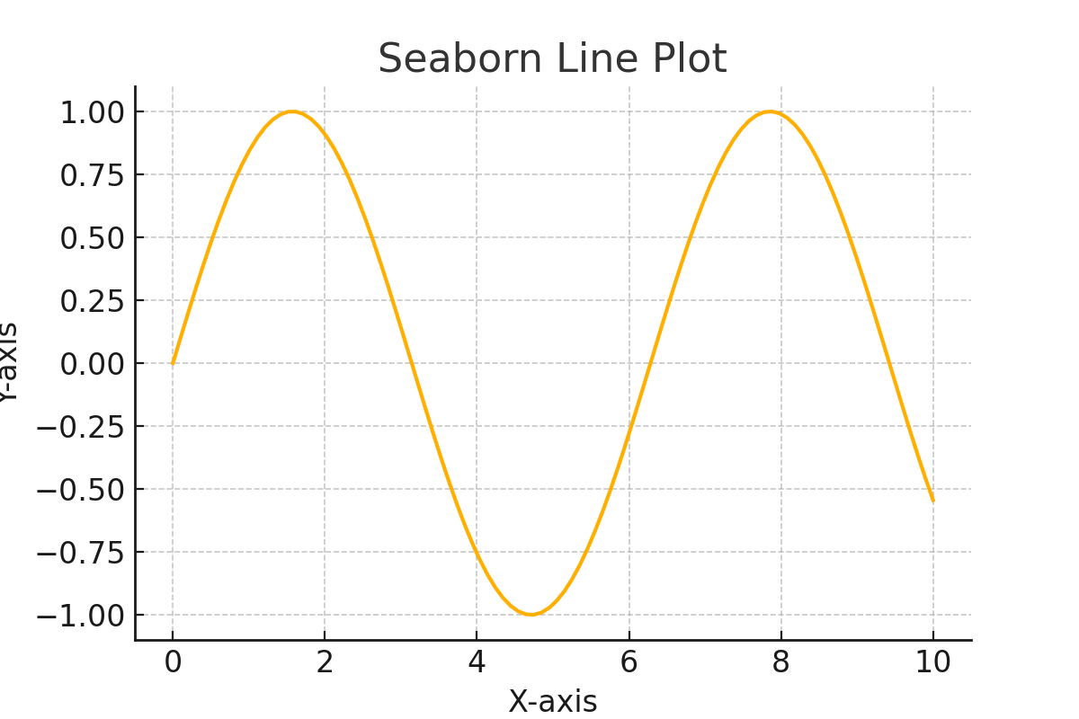

## ****2.2 Scatter Plot****

### ****Use Case:**** Relationship between two variables.

**Matplotlib Example:**

import matplotlib.pyplot as plt

import numpy as np

x = np.random.rand(50)

y = np.random.rand(50)

plt.scatter(x, y, color='blue')

plt.xlabel('X-axis')

plt.ylabel('Y-axis')

plt.title('Scatter Plot')

plt.show()

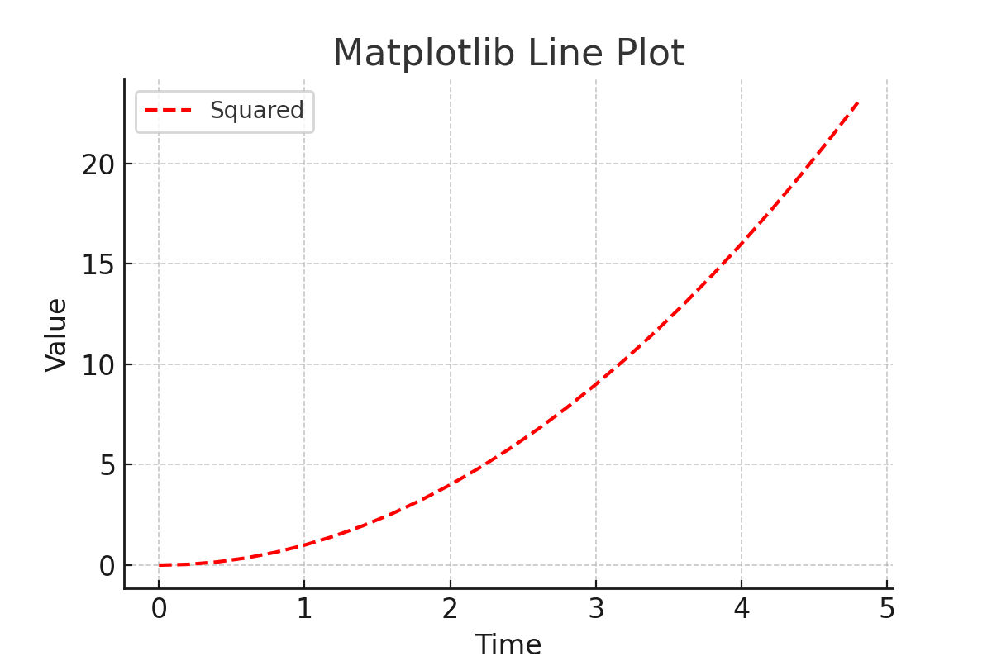

**Seaborn Example:**

import seaborn as sns

import pandas as pd

df = pd.DataFrame({'x': np.random.rand(50), 'y': np.random.rand(50)})

sns.scatterplot(x='x', y='y', data=df)

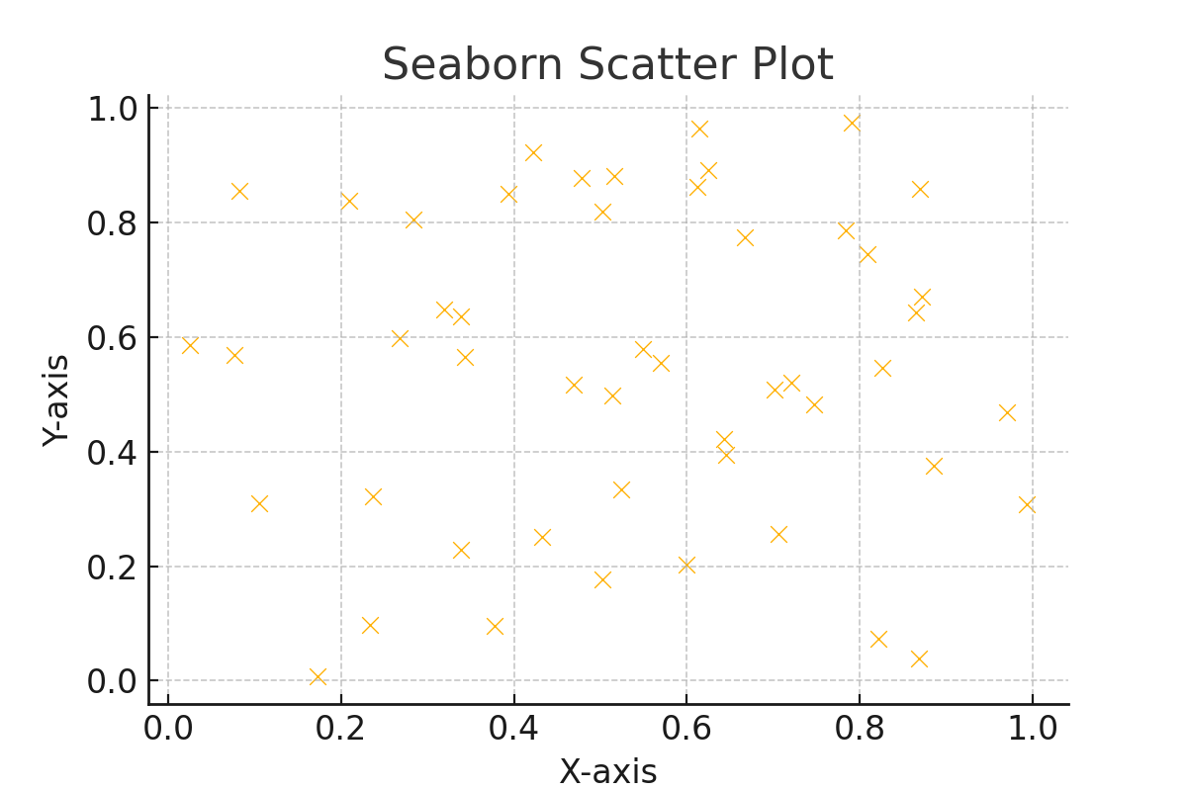

**2.3 Bar Chart**

**Use Case: Comparing categorical data.**

**Matplotlib Example:**

categories = ['A', 'B', 'C']

values = [10, 20, 15]

plt.bar(categories, values)

plt.xlabel('Categories')

plt.ylabel('Values')

plt.title('Bar Chart')

plt.show()

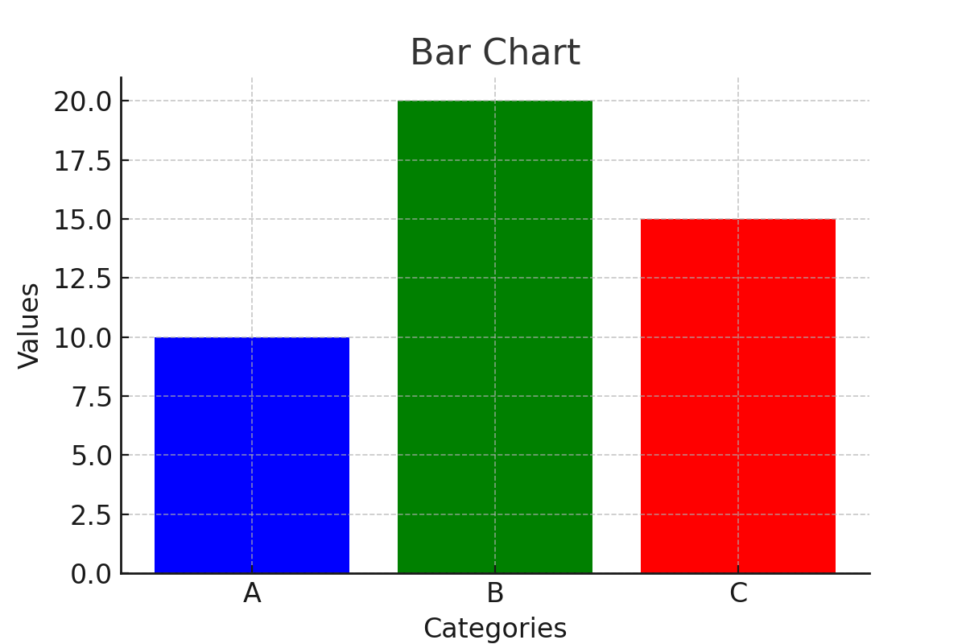

**Seaborn Example:**

sns.barplot(x=['A', 'B', 'C'], y=[10, 20, 15])

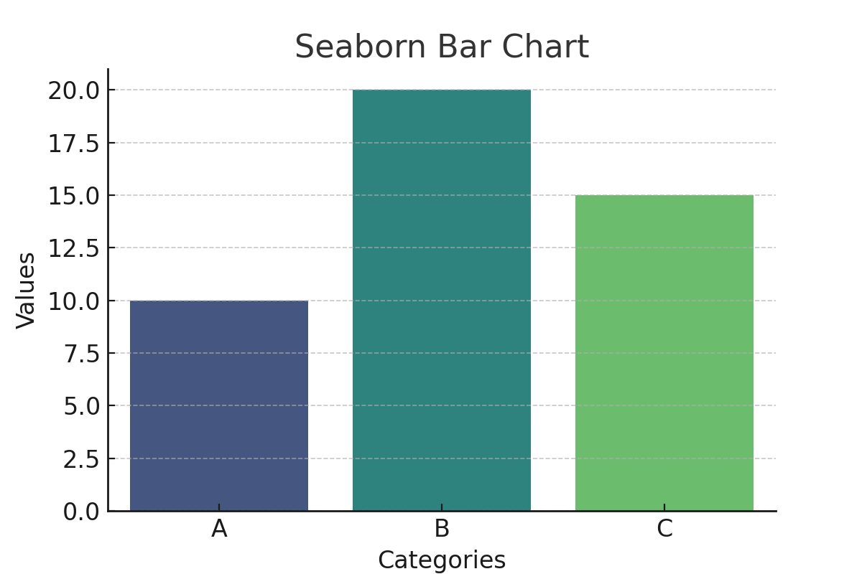

**2.4 Histogram**

**Use Case: Distribution of data.**

**Matplotlib Example:**

data = np.random.randn(1000)

plt.hist(data, bins=30, alpha=0.7, color='g')

plt.xlabel('Value')

plt.ylabel('Frequency')

plt.title('Histogram')

plt.show()

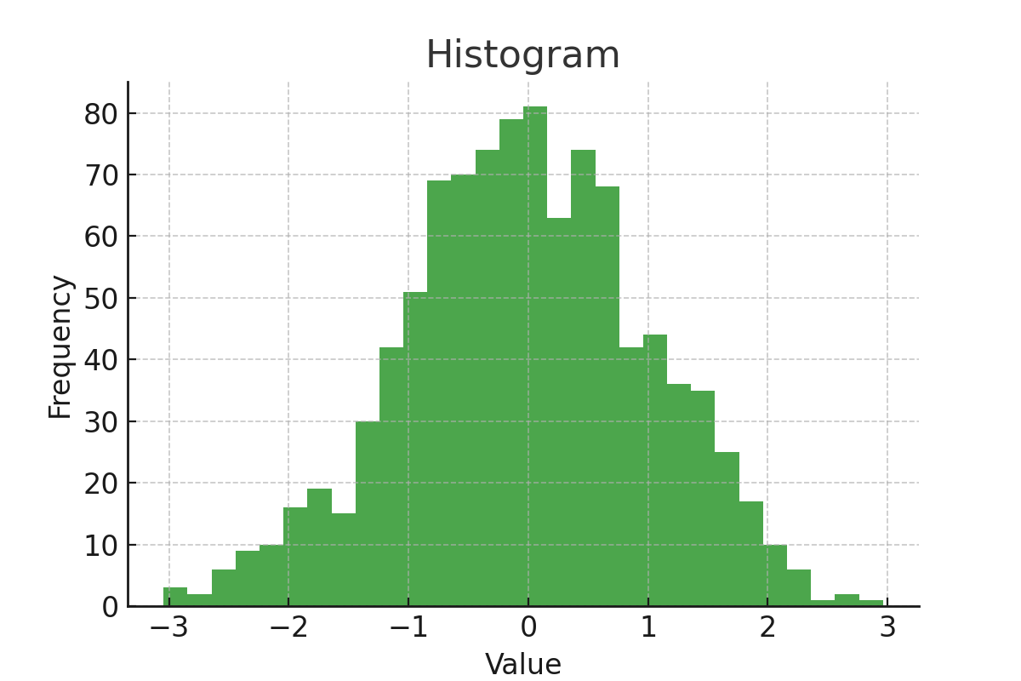

**Seaborn Example:**

sns.histplot(data, bins=30, kde=True)

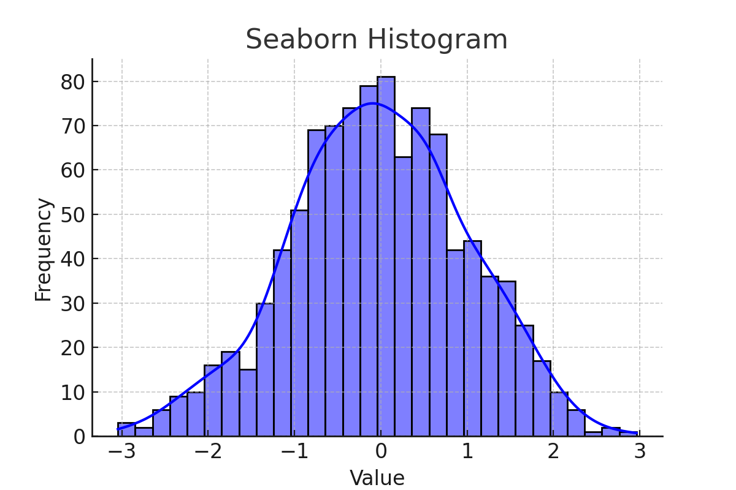

**2.5 Heatmap**

**Use Case: Visualizing correlation matrices.**

**Seaborn Example:**

import numpy as np

import seaborn as sns

import pandas as pd

data = np.random.rand(10, 10)

df = pd.DataFrame(data)

sns.heatmap(df, cmap='coolwarm', annot=True)

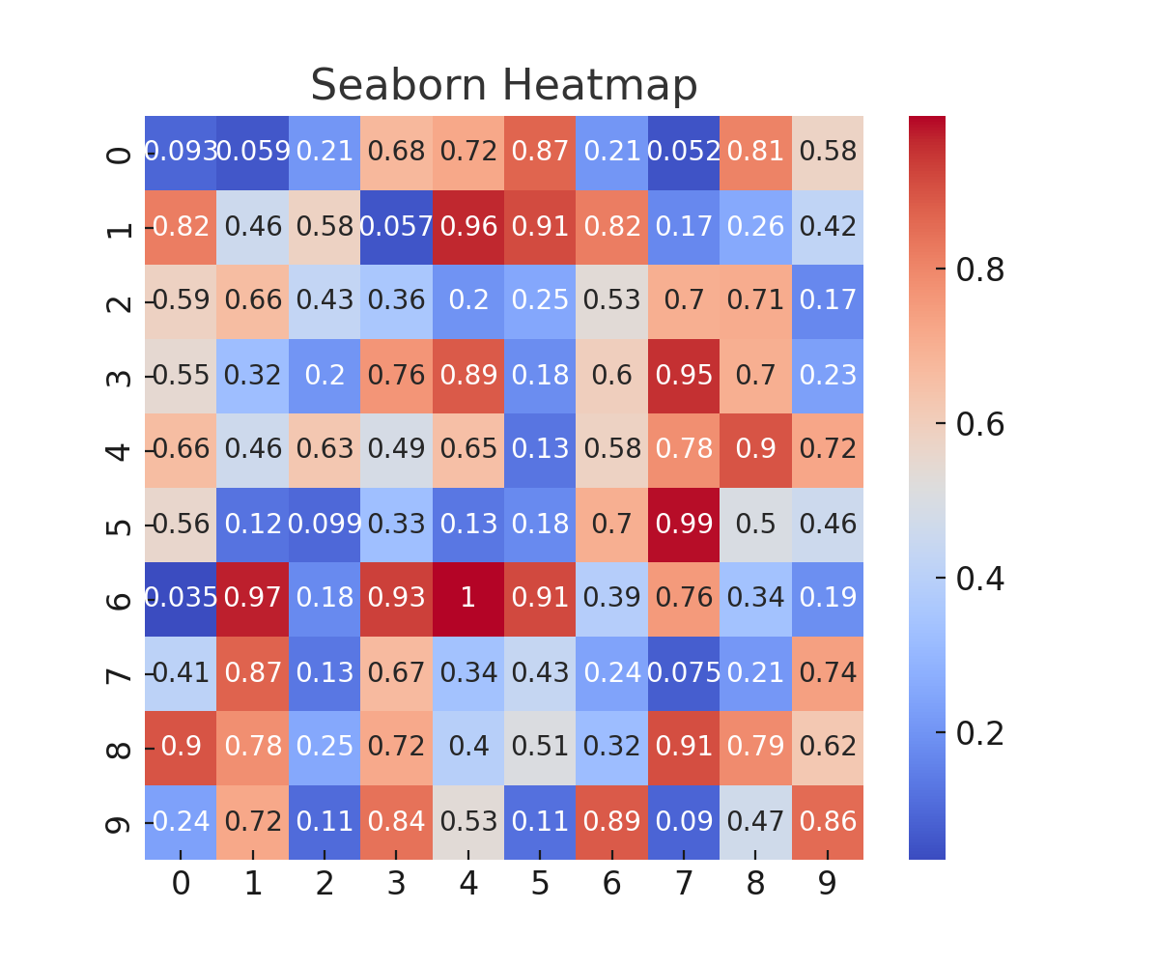

**3. Comparison of Matplotlib and Seaborn**

| **Feature** | **Matplotlib** | **Seaborn** |
| --- | --- | --- |
| Ease of Use | Moderate | High |
| Customization | Extensive | Moderate |
| Interactivity | Limited | Limited |
| Aesthetics | Basic | Advanced |
| Performance | High | High |

**3.1 Strengths and Weaknesses**

**Matplotlib**

✅ Highly customizable ✅ Supports a wide range of plot types ❌ Requires more code for styling ❌ Basic aesthetics by default

**Seaborn**

✅ Beautiful default themes ✅ Simplifies statistical plots ❌ Less customizable than Matplotlib ❌ Not ideal for low-level plotting control

**4. Conclusion**

Matplotlib and Seaborn are powerful tools for data visualization in Python. **Matplotlib** is preferred for highly customizable plots, while **Seaborn** is ideal for quick and aesthetically pleasing statistical graphics. Depending on the use case, combining both libraries can yield the best results.

By mastering these libraries, analysts and developers can create compelling visualizations to communicate data-driven insights effectively.